MINI PROJECT

SUBJECT: web development

NAME: Noor Sabah Yahya AL-azzawi

INTAKE: September 2018

ID: BIT18096535

**Introduction:**

For a starter working on this website was an interesting thing, I have learned several things just to get the work done.

The website is about my self, promoting my self to others and interduce who am I, for the most part the website was not a hard thing to make but the design phase was tricky. How to make a simple website that will make any user interested to go on and dive deep in it instead of making a boring one that will drive users away. The website contains four main pages the first one is the home page and then the profile page that contain information about my self, then the contact page that contain the contact information and the contact form also has an introduction video. Then the album page that contain some images that was taken by me and sorted in an album slider.

**Storyboard:**

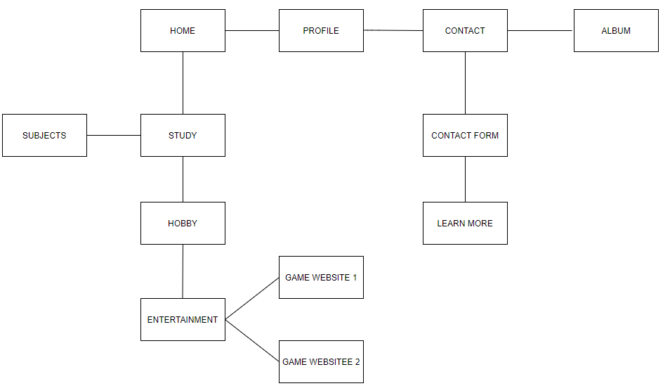

**User interface:**

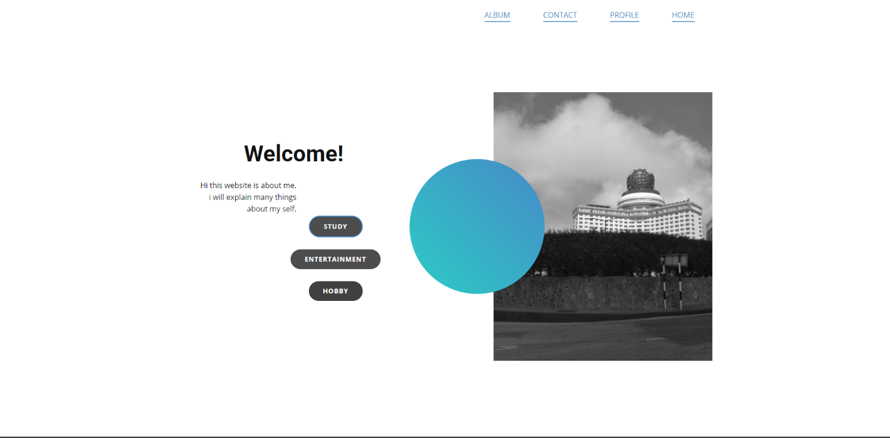

A screen shot showing the home page of the website and it contains the four main pages the home page and contact page and profile page and the album that contains a picture slider. As for the home page it contains three main buttons each leads to a sub page the hobby one and entertainment and study each contain several buttons leads to external web pages.

**Website code:**

Below is the main index file code:

<!DOCTYPE html>

<html style="font-size: 16px;">

<head>

<meta name="viewport" content="width=device-width, initial-scale=1.0">

<meta charset="utf-8">

<meta name="keywords" content="Welcome!">

<meta name="description" content="">

<meta name="page_type" content="np-template-header-footer-from-plugin">

<title>HOME</title>

<link rel="stylesheet" href="nicepage.css" media="screen">

<link rel="stylesheet" href="HOME.css" media="screen">

<script class="u-script" type="text/javascript" src="jquery.js" defer=""></script>

<script class="u-script" type="text/javascript" src="nicepage.js" defer=""></script>

<meta name="generator" content="Nicepage 3.4.1, nicepage.com">

<link id="u-theme-google-font" rel="stylesheet" href="https://fonts.googleapis.com/css?family=Roboto:100,100i,300,300i,400,400i,500,500i,700,700i,900,900i|Open+Sans:300,300i,400,400i,600,600i,700,700i,800,800i">

<script type="application/ld+json">{

"@context": "http://schema.org",

"@type": "Organization",

"name": "",

"url": "index.html"

}</script>

<meta property="og:title" content="HOME">

<meta property="og:type" content="website">

<meta name="theme-color" content="#478ac9">

<link rel="canonical" href="index.html">

<meta property="og:url" content="index.html">

</head>

<body data-home-page="HOME.html" data-home-page-title="HOME" class="u-body"><header class="u-clearfix u-header u-header" id="sec-72d8"><div class="u-clearfix u-sheet u-sheet-1">

<a href="file:///C:/Users/Noor-Alazzawi/Desktop/new%20website/index.html" class="u-active-none u-border-2 u-border-palette-1-base u-btn u-btn-rectangle u-button-style u-hover-none u-none u-btn-1">HOME</a>

<a href="PROFILE1.html#carousel_44dc" data-page-id="73285203" class="u-active-none u-border-2 u-border-palette-1-base u-btn u-btn-rectangle u-button-style u-hover-none u-none u-btn-2">PROFILE</a>

<a href="CONTACT.html#sec-850b" data-page-id="1272015971" class="u-active-none u-border-2 u-border-palette-1-base u-btn u-btn-rectangle u-button-style u-hover-none u-none u-btn-3">CONTACT<br>

</a>

<a href="ALBUM.html" data-page-id="184408731" class="u-active-none u-border-2 u-border-palette-1-base u-btn u-btn-rectangle u-button-style u-hover-none u-none u-btn-4">ALBUM<br>

</a>

</div></header>

<section class="u-clearfix u-white u-section-1" id="carousel_fcd0">

<div class="u-clearfix u-sheet u-sheet-1">

<a href="https://nicepage.com" class="u-btn u-btn-round u-button-style u-hover-palette-1-light-1 u-palette-1-base u-radius-50 u-btn-1">Button</a>

<div class="u-clearfix u-expanded-width u-layout-wrap u-layout-wrap-1">

<div class="u-layout">

<div class="u-layout-row">

<div class="u-align-right u-container-style u-layout-cell u-right-cell u-size-26 u-white u-layout-cell-1">

<div class="u-container-layout u-container-layout-1">

<h1 class="u-text u-text-1">Welcome!</h1>

<p class="u-text u-text-2">Hi this website is about me.<br>i will explain many things about my self.

</p>

<a href="STUDY-.html" data-page-id="99919063" class="u-border-2 u-border-hover-palette-1-base u-border-palette-1-base u-btn u-btn-round u-button-style u-grey-70 u-hover-grey-90 u-radius-50 u-btn-2">STUDY</a>

<a href="ENTERTAINMENT.html" data-page-id="129606383" class="u-btn u-btn-round u-button-style u-grey-70 u-hover-grey-90 u-radius-50 u-btn-3">ENTERTAINMENT</a>

<a href="HOBBY.html" data-page-id="942743" class="u-btn u-btn-round u-button-style u-grey-75 u-hover-grey-90 u-radius-50 u-btn-4">HOBBY</a>

</div>

</div>

<div class="u-container-style u-layout-cell u-left-cell u-size-34 u-white u-layout-cell-2">

<div class="u-container-layout u-container-layout-2">

<img src="images/ss3.jpg" alt="" class="u-image u-image-default u-image-1">

<div class="u-gradient u-shape u-shape-circle u-shape-1"></div>

</div>

</div>

</div>

</div>

</div>

</div>

</section>

<footer class="u-align-center u-clearfix u-footer u-grey-75 u-footer" id="sec-5de5"><div class="u-clearfix u-sheet u-sheet-1">

<p class="u-small-text u-text u-text-variant u-text-1">Email: BIT18096535@mahsastudent.edu.my<br>Phone number: 0109580903

</p>

</div></footer>

<section class="u-backlink u-clearfix u-grey-80">

<a class="u-link" href="https://nicepage.com/website-templates" target="_blank">

<span>Website Templates</span>

</a>

<p class="u-text">

<span>created with</span>

</p>

<a class="u-link" href="https://nicepage.com/" target="_blank">

<span>Website Builder Software</span>

</a>.

</section>

</body>

</html>

**Conclusion:**

In the end working on this website was really fun and I am thankful for it, while working on this website got me to learn many things, I had to learn many different programing languages to get this website up such as CSS, HTML, PHP.

Designing a website it is not easy as it seems, the coding part was the easy and simple part about making a website but on the other hand the hard part was how to get and design a user friendly interface to get the users to be interested in using the website rather then having the user to be bored and confused. Having a simple website with simple colors is important to make the texts easy to read rather than using colorful colors and making the text difficult to read.

I am happy with the end result as for this is one of my first websites to develop by my own and I got a nice clean website that is easy to use and work with.